**DesignTask**

**Tasks:**

The project is expected to be in a functioning form and relatively bug free. It should be independently deployable**.**

Candidate is required to provide a link to a private Github project. We have a strong preference for ReactJS andBootstrap.

**Task 1**  
Candidates are required to implement a “**Hiring Portal**” plugin using ReactJS (Redux, Axios) for frontend.

**Minimal Requirements for Application:**

**\*NOTE: All the actions should be performed asynchronously.**

* **Step 1:** Candidate has to select a domain.  
  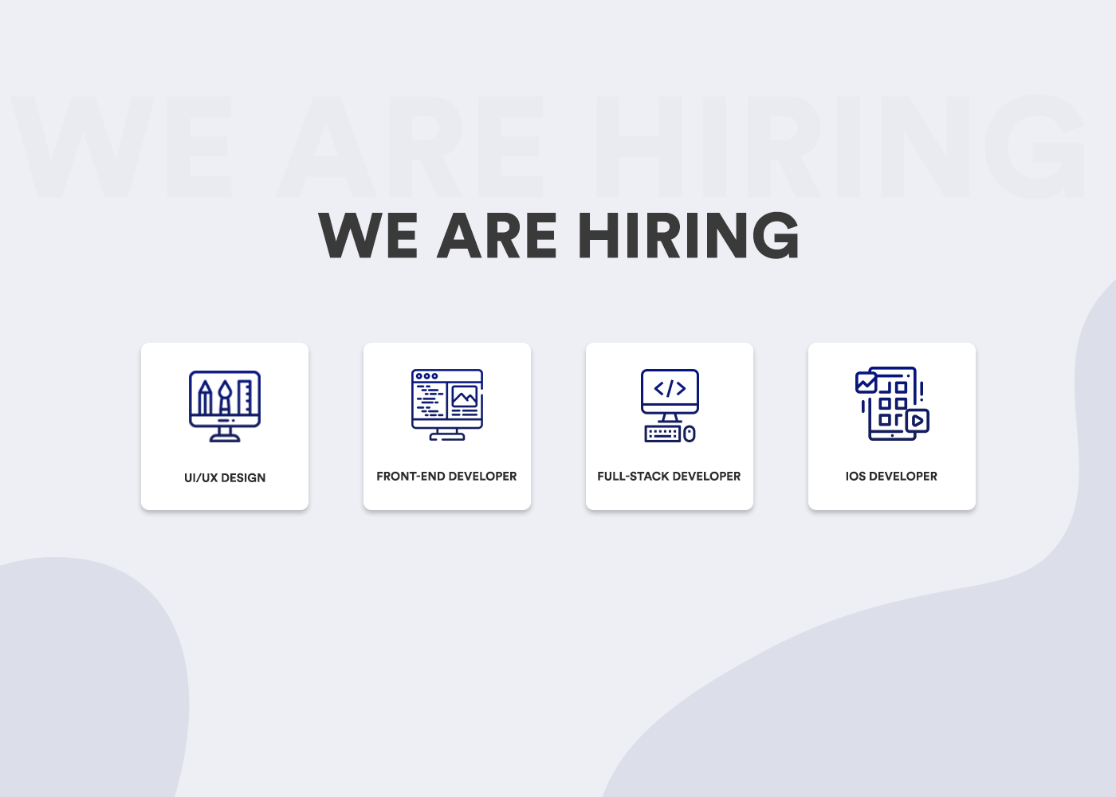
* **Step 2:** After selecting the domain candidate can upload his resume. Candidates should be able to delete the selected file.  
  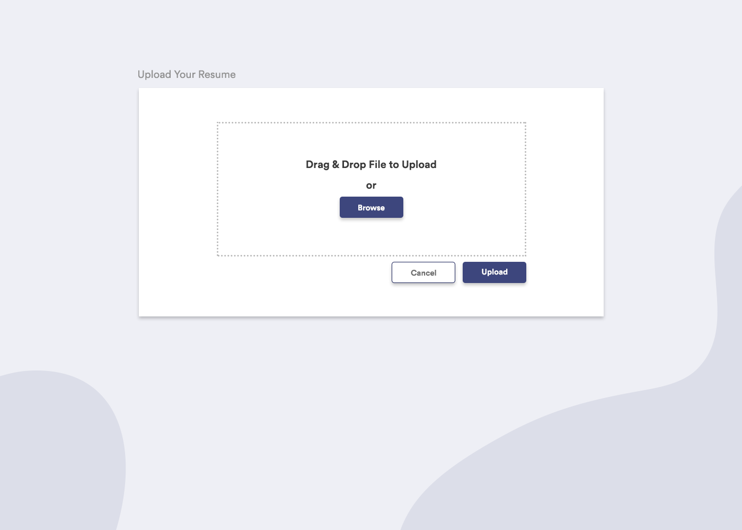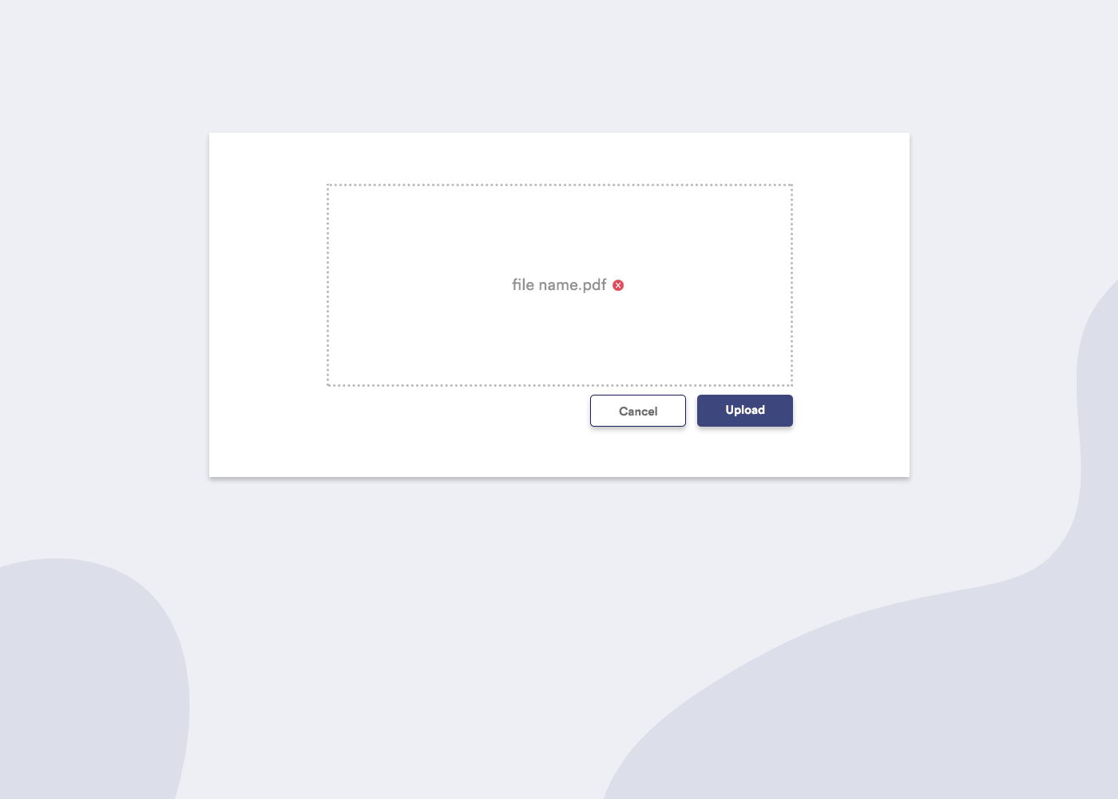
* **Step 3:** Candidate has to fill the required form which should be saved in the database. As shown in the pictures below before submitting the form all data that candidate has entered should be displayed to verify information he has entered. Once the user has submitted the form successfully, the email should be sent to [example@abc.com](mailto:example@abc.com) (You can choose any email for testing) with the user's name, email and contact number.  
  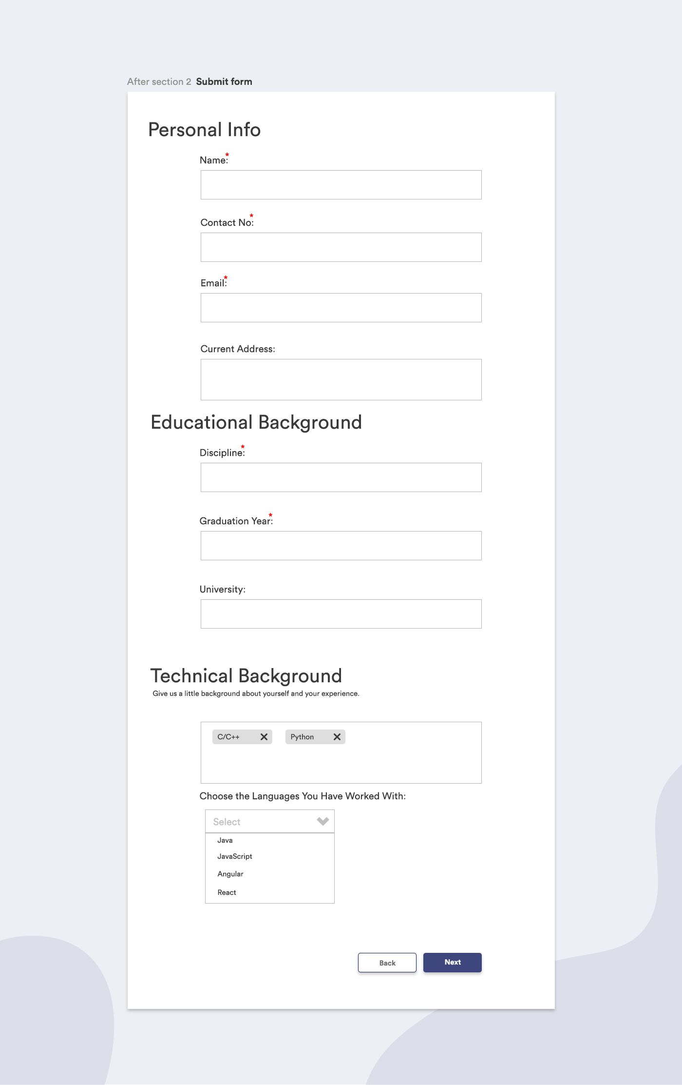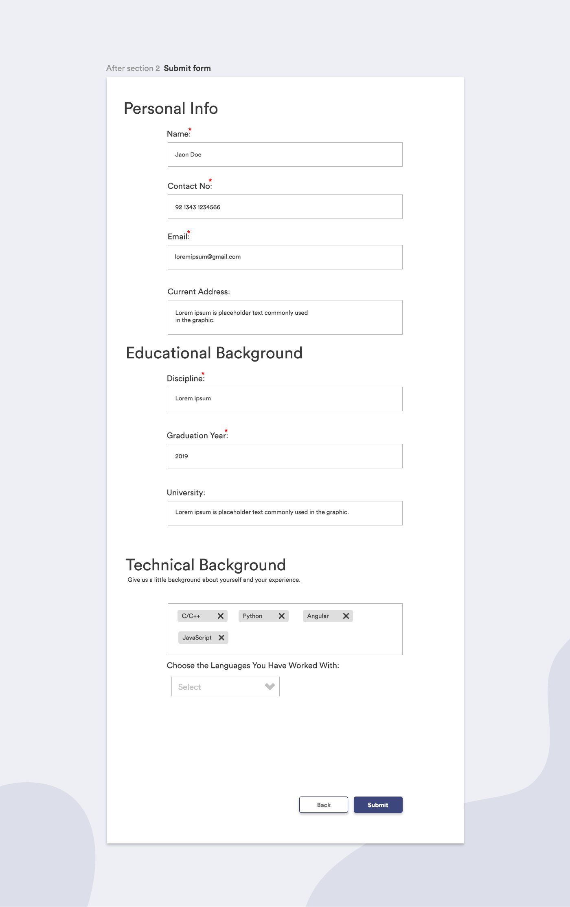

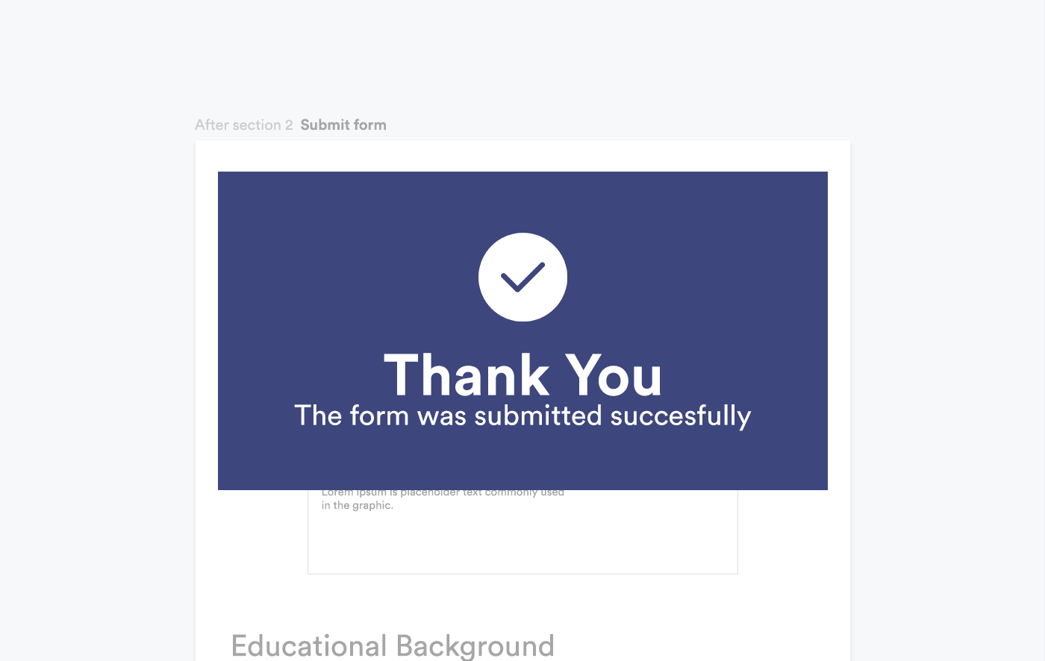

* Admin view should have basic primary features like:  
  - Search candidate  
  - Filter candidate based on date  
  - Admin can delete a candidate  
  - Admin can view short listed candidate
* On the admin side we would have a page where an admin can view all the registered candidates along with their resumes and also there should be a pie chart that would represent how many users have applied for which specific domain.

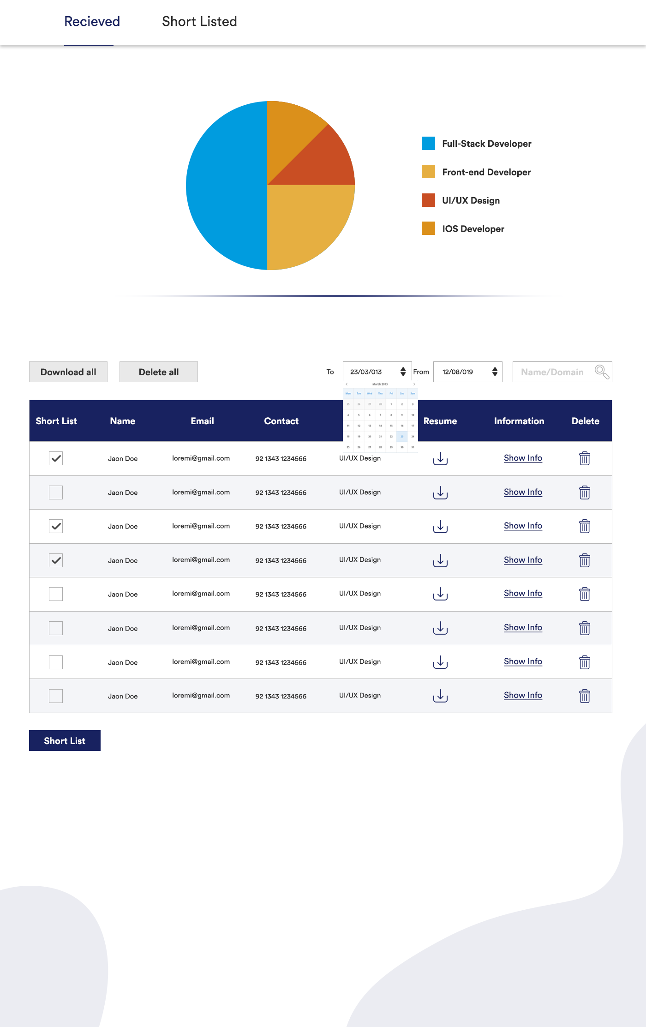

* In the admin view there should be another page which would display shortlisted candidates with a bar chart which would display the shortlisted candidates along with their domain.  
    
  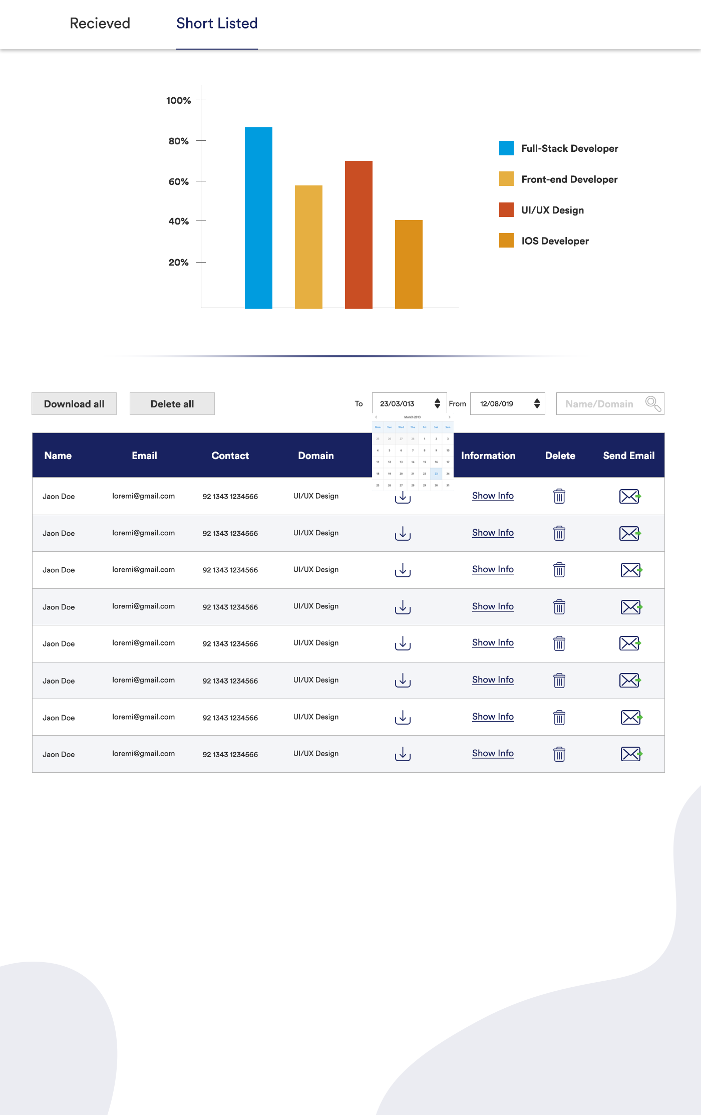
* Admin should be able to view detailed information of candidates by clicking the **Show Info** button in both tables.

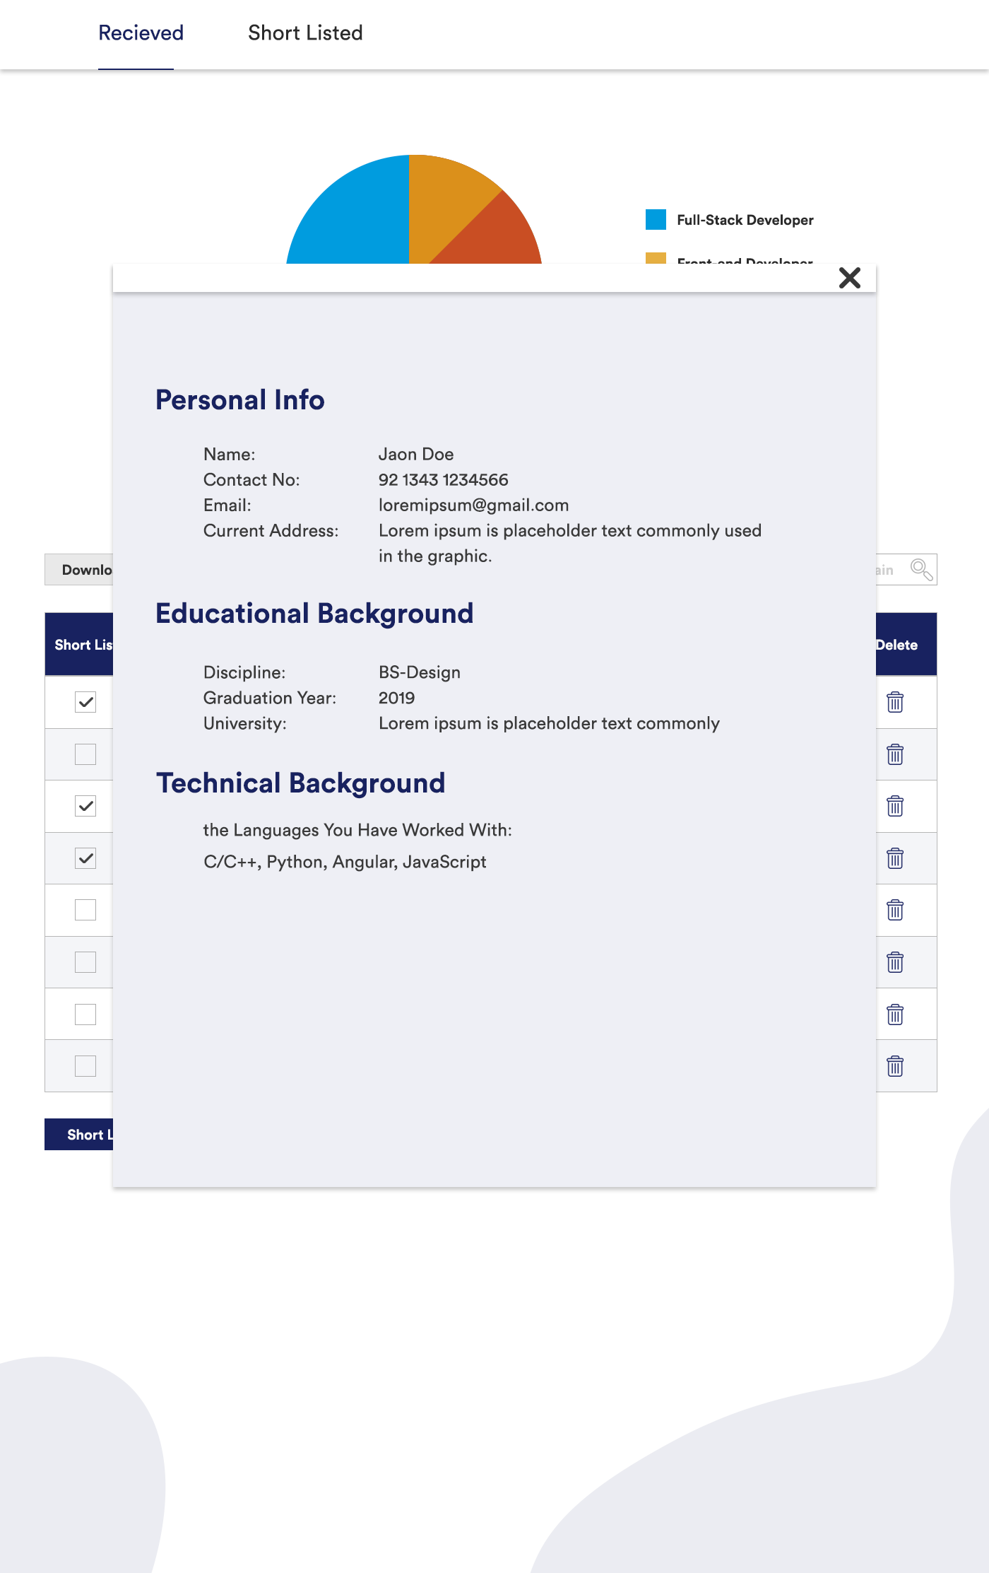

Note that this design task is intentionally left open ended instead of dictating specifics. We would like to see what kind of design decisions and conventions you end up adhering to. One more thing we would like you to explain is whether you think there are any problems/vulnerabilities/limitations in the submitted solution? If yes, please explain why.

**Requirements:**

Take all the shortcuts necessary to complete the task in time. The architecture is not important for this assignment. The main aim of this exercise is to gauge the applicant’s ability to use all the required tools to develop a functioning project. Scalability of the system should also not be of much concern for this task, although the candidate is expected to provide his ideas for system architecture and scale during his technical interview.

The goal is to create a working demo with the necessary build setup. Prioritize showing a working demo of the setup over completing all the needed features. Create README/installation instructions for the tools being used.